Cloud Phone System using AWS

This project will be using the AWS free tier and 3cx (free for a year).

Projected time: 45 minutes

Project price: free (AWS free tier/3cx free for a year)

**Preparation phase**

1. User creation and EC2

In the AWS console will be going to the IAM service,

* Creation of “3cx” user.
* Select “Attach policies directly” and add “AmazonEC2FullAccess” and “ServiceQuotasFullAccess”.

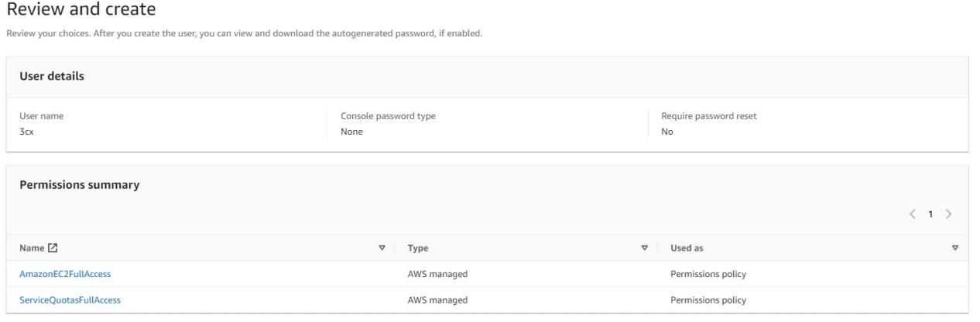

* After “3cx” user is created, go to the Security credentials tab and scroll down to “Create access key” and create access keys using the “Application running on an AWS compute service “ option.
* Navigate to EC2 Dashboard, create key pair, name the key pair “3cxkeypair” using pem file format. Save the keypair file.
* Open AWS Marketplace and subscribe to Debian 10 Buster.

1. Setup 3cx (https://www.3cx.com/)

* Create an account
* Select “Add System”, select “Self hosted (On Premise / Private Cloud)”, “Self-hosted with your cloud provider”, choose your hostname and domain close it to you, add users, pick “Amazon - AWS” as cloud provider and use the access keys created on step 1.
* Set the extension, I preferred the 4 digits, but you can pick which ever you one.
* Configure your OS, select your time zone, and Language.
* Set your machine name, select your AWS region, select your keypair keys that you created in step 1, and select the machine type: t2.micro. (This process will take around 7-10 minutes)
* Save your web access, username and password.
* Install the 3cx app in your phone

1. Setup Amazon Chime

* Create new account and use all available regions.
* Click on “Phone number management” and go to orders and Provision phone numbers. Select Voice Connectors, on Type select “Toll Free or Local number”.
* Click on “Voice connectors” and create a new voice connector. Name your voice connector, pick your region and disabled encryption.Configure your new voice connector.
  + Termintaion tab - enabled termination status and add a new host list. On the CIDr notation input the public address from your EC2. On the calling plan, add your country. Create new credentials. Save your configuration.
  + Origination tab - enabled origination status and add a new inbound route. Login to your 3cx dashboard and copy your FDQN into your host and keep the standard configuration. Save your configuration.
  + Phone number tab - assign your number from your inventory.

1. Setup your 3cx dashboard

* SIP Trunk tab - Add SIP trunk and add your country where you are going to be using the PBX. Select Amazon Chime and add the number you created on it.
* The registar will be the “Outbound host name” from the voice connectors section in AWS chime.
* On authentication, input the credentials created earlier on the Amazon Chime setup.
* Setup outbound rules - change the number prefix to start with 9.
* Save configuration.